**TURBO CAR RENTAL**

USER MANUAL

**Submitted by**:

Valenzona, Mark Joseph

Paraguya, André Paulo

**Submitted to**:

Sir [Paul John Parreño](https://www.facebook.com/paul.j.parreno?fref=nf)

**Submitted on**:

October 17, 2014

**TABLE OF CONTENTS**

SYSTEM OVERVIEW **I**

SIGN UP **1**

LOGIN **2**

FORGOT PASSWORD **3**

MAIN MENU **4**

NEWS/EVENTS **4**

ABOUT US **5**

MY PROFILE **6**

RENT A CAR **7**

LOG OUT **8**

# **SYSTEM OVERVIEW**

* The Turbo Car Rental application is a car reservation system which caters to customers who have just arrived, or plan to be in the vicinity of Cebu and want to have a temporary car for personal use.
* The application is developed using Android Jellybean.
* End users will navigate through the application using a GUI.
* An unregistered user may need to sign up for an account to use the application, but a Facebook or Google Plus account may be used to login if the user does not want to sign up.
* The app allows an end user to view relevant news and events.
* The app allows an end user to view his/her profile information and the user may change profile information if he/she wishes to do so.
* The app allows an end user to view the company’s profile information.
* The app allows an end user to reserve a car by undergoing a short procedure.
* The app allows an end user to view his/her current reservations and the user may cancel a reservation if he/she wants to.
* The app allows end users to log out of their accounts anytime.

# **SIGN UP**

Select the “Sign Up for Turbo” link.

You will be redirected to the Registration page after clicking the link.

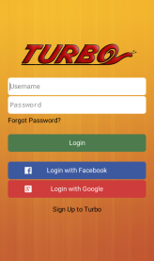

Supply all forms with the required data.

Note: It’s necessary to upload a valid photo. This will be used for identification. A photo can be chosen from the gallery.

After supplying all the required data and pressing the Submit button, you will be redirected to the login page.

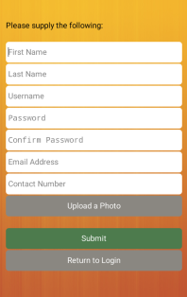

# **LOGIN**

On the login page, the user will be asked to input his/her username and password.

The user also has the option to login with a Facebook or Google Plus account.



# **FORGOT PASSWORD**

On the login page, a registered user may press the “Forgot Password?” link if ever he/she forgets his/her password.

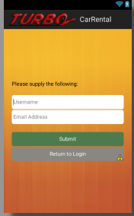After the “Forgot Password” link is pressed, the user is redirected to a page where he/she is asked to input a username and email address. The username will be the identifier for the user account and the email address will be where the password will be sent.

# **MAIN MENU**

After successfully logging in, the user is redirected to the main menu.

On the main menu, the user can either choose either to go to the RENT A CAR page, MY PROFILE page, NEWS/EVENTS page, or ABOUT US page.

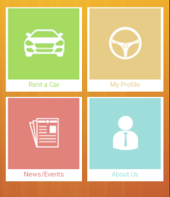

## **ABOUT US**

The ABOUT US page could be accessed through the MAIN MENU.

The page displays 2 tabs: COMPANY PROFILE and ABOUT

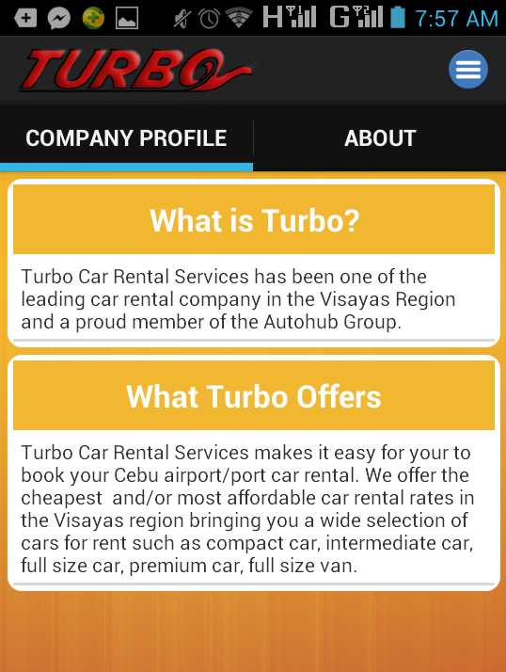The default tab is COMPANY PROFILE.

If the user selects the ABOUT tab, more detail with regard to the company’s profile is displayed.

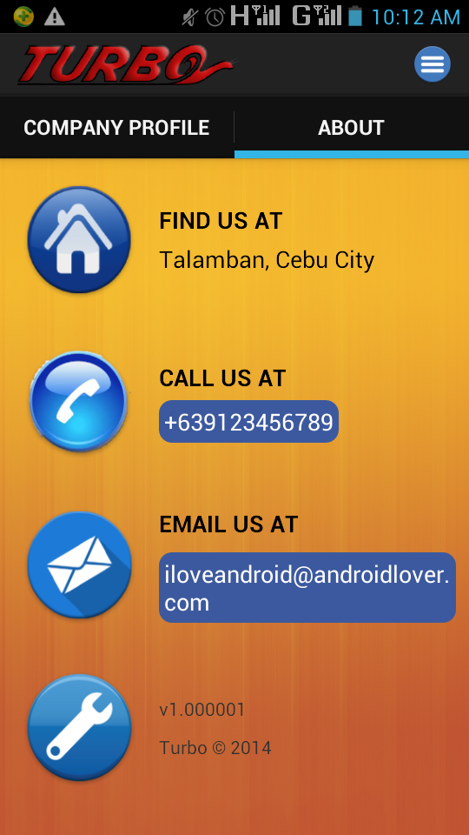

## **MY PROFILE**

The MY PROFILE page could be accessed through the MAIN MENU.

The page displays 2 tabs: MY PROFILE and MY RENTALS.

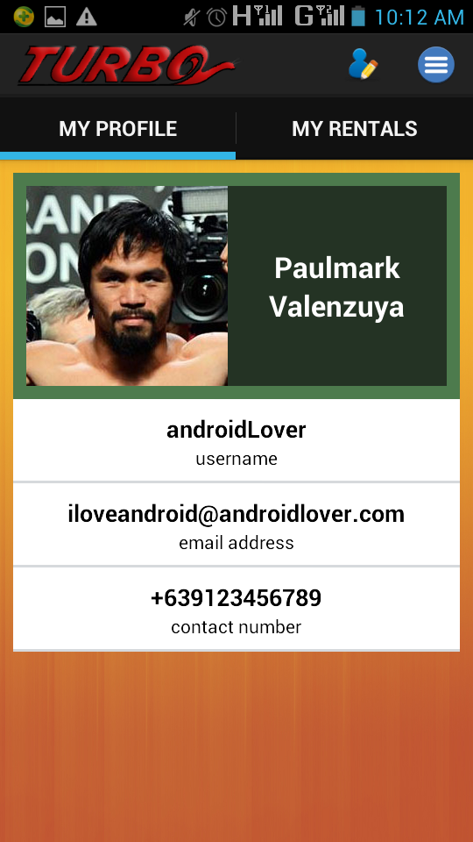The default tab is MY PROFILE which displays the user’s profile information. The user can change profile information through the EDIT PROFILE button.

If the user selects the MY RENTALS tab, a list of the user’s reservations with rental details are displayed.

The user may cancel a reservation by selecting the CANCEL RESERVATION button provide for each element on the list.

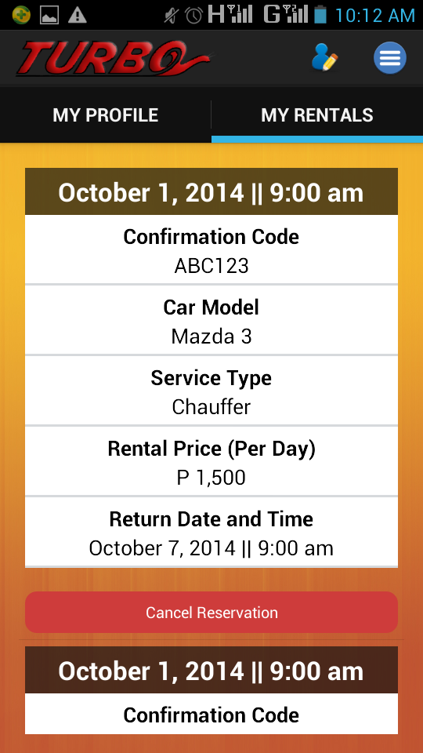

### **EDIT PROFILE**

The user can edit his/her profile information by pressing the EDIT PROFILE on the MY PROFILE TAB.

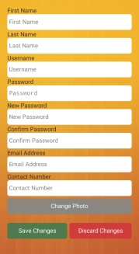

## **RENT A CAR**

The RENT A CAR page could be accessed through the MAIN MENU.

1st step: CHOOSE A CAR

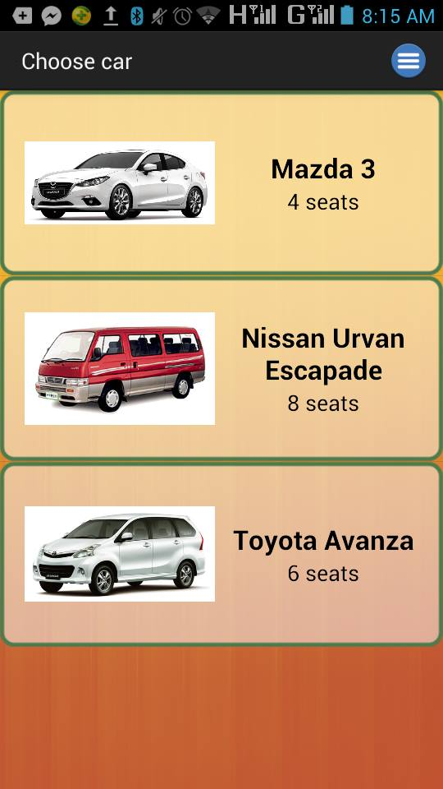

2nd step: SUPPLY THE REQUIRED FIELDS for rental information

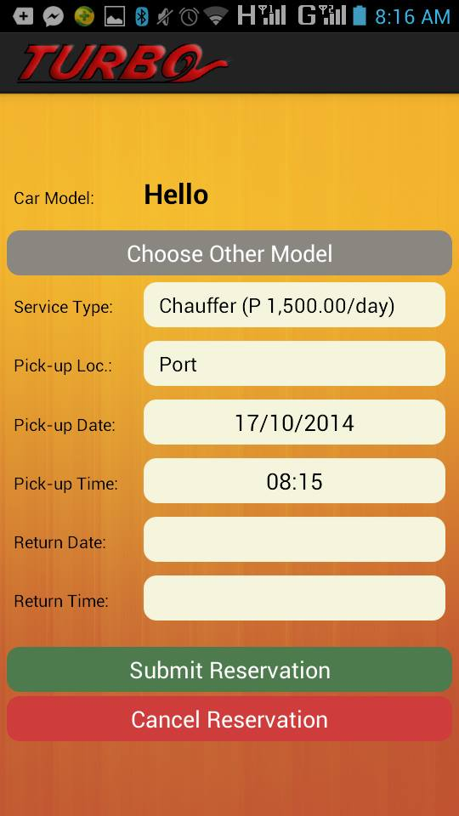

## **NEWS/EVENTS**

The NEWS/EVENTS page could be accessed through the MAIN MENU.

The page displays a list of news and events and the user may select an element on the list to view its contents.

If the user selects an element on the list of news and events, the user will be redirected to a page where the full details are shown.

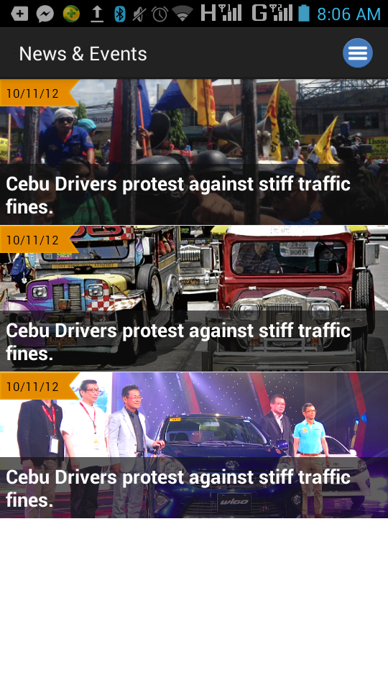

# **LOG OUT**

The user may log out from his/her account anytime through the log out icon on the MAIN MENU.

